

# Task 2 – Pass Submission

Student Number: 103181157  
Student Name: Nguyen Nam Tung

### Pass 2a

Paste your screen capture(s) for this task here.

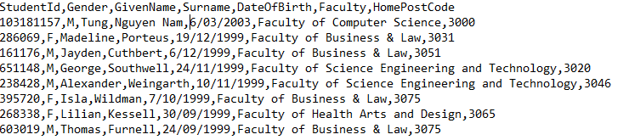

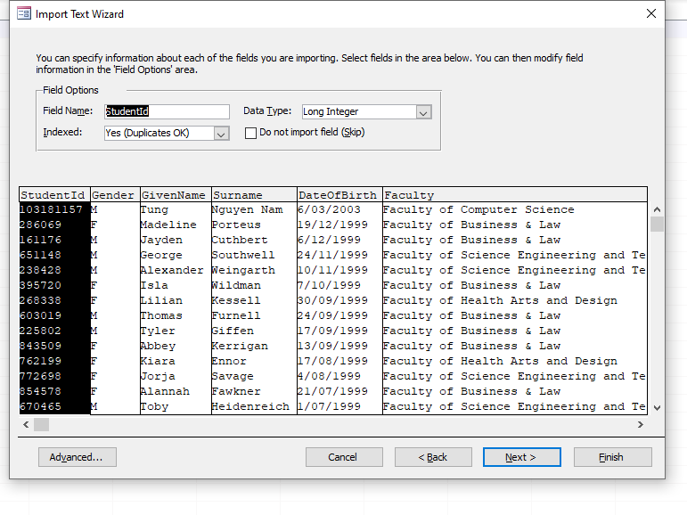

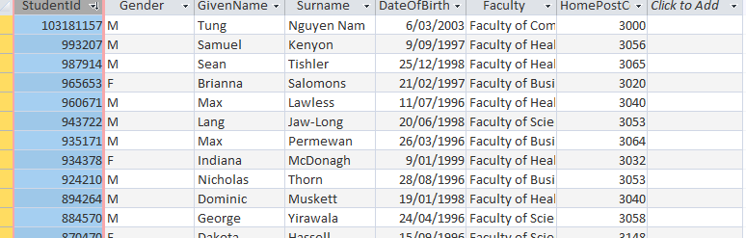

### Pass 2b

Paste your screen capture(s) for this task here.

1. A csv file is opened in Excel rather than Notepad because the default format of It is Excel
2. In order to open in Notepad:

* Window -> Apps -> Default App ->Default Apps by file types -> Choose file we want to change
* Use open with

### Pass 2c

Paste your screen capture(s) for this task here.

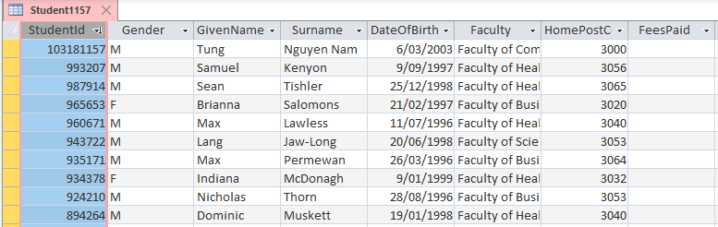

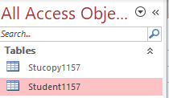

### Pass 2d

Paste your screen capture(s) for this task here.

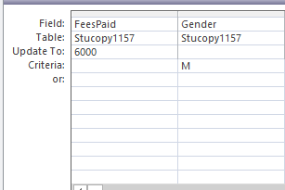

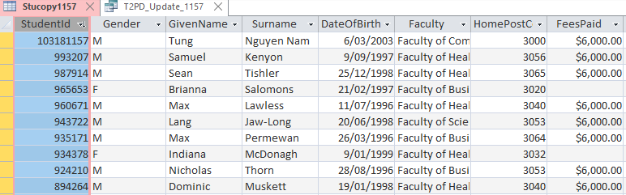

### Pass 2e

Paste your screen capture(s) for this task here.

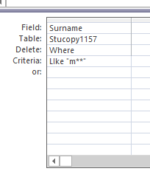

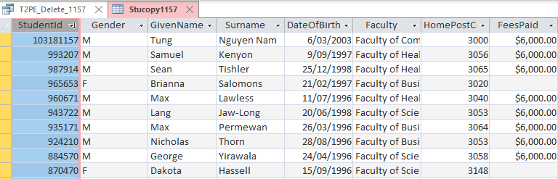

### Pass 2f

Paste your screen capture(s) for this task here.

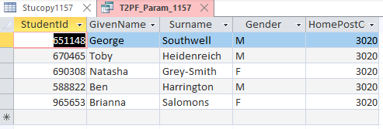

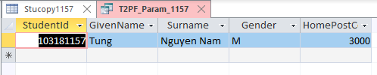

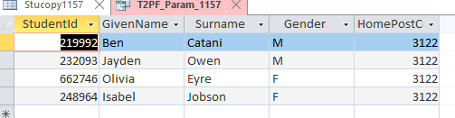

### Pass 2g

Paste your screen capture(s) for this task here.

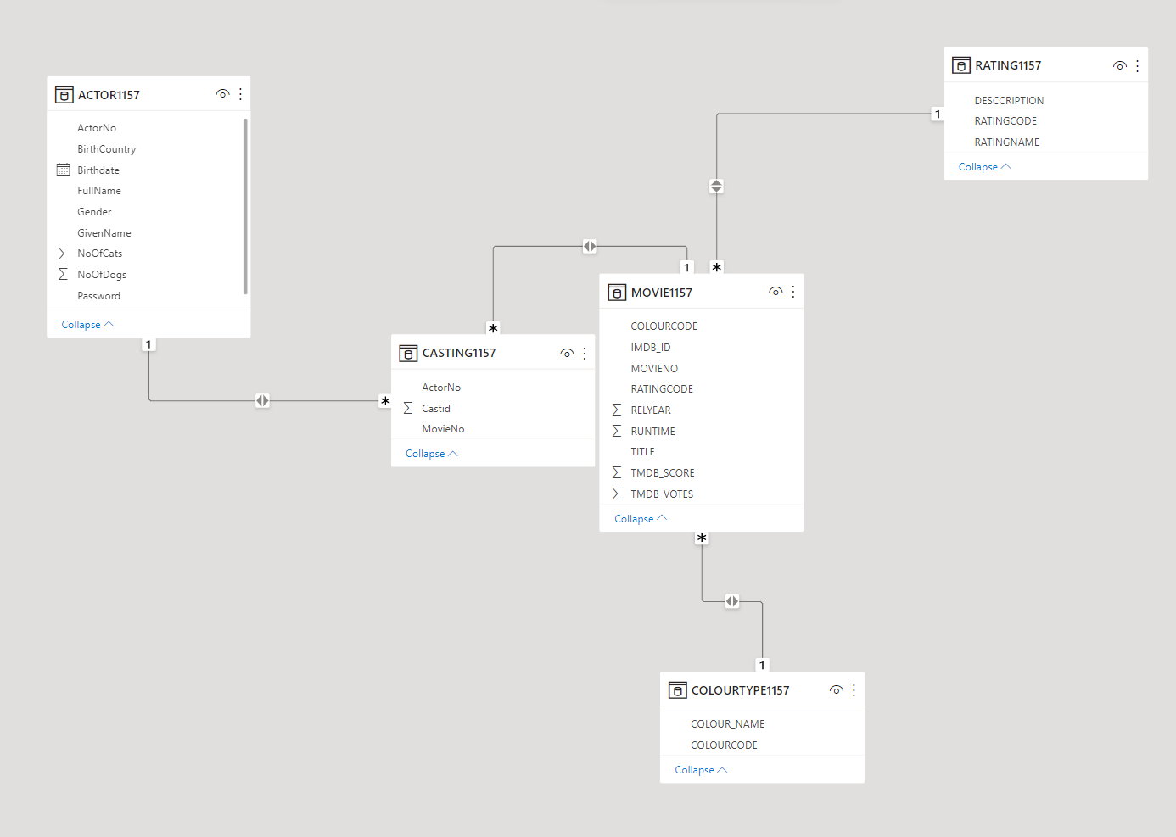

### Pass 2h

Paste your screen capture(s) for this task here.

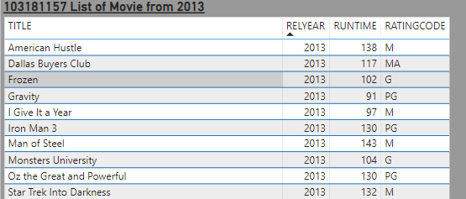

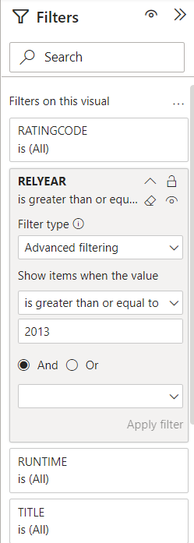

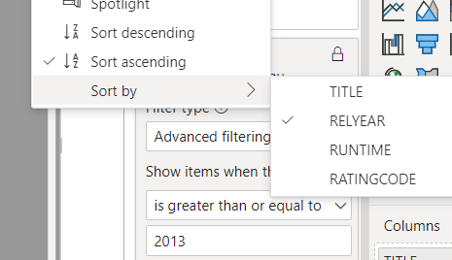

### Pass 2i

Paste your screen capture(s) for this task here.



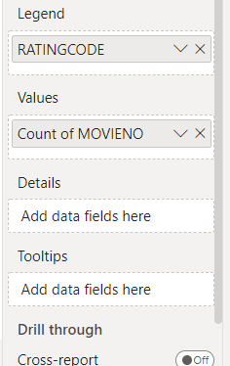

### Pass 2j

Paste your screen capture(s) for this task here.

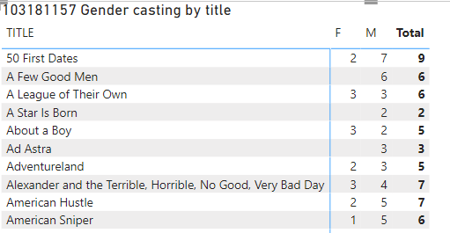

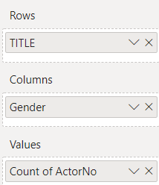

### Pass 2k

Paste your screen capture(s) for this task here.

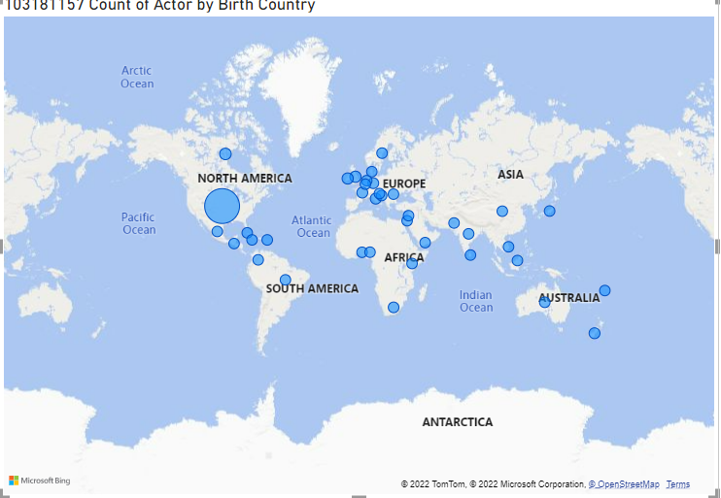

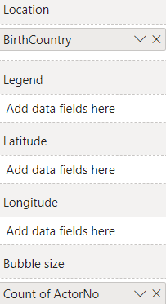

### Pass 2l

Paste your screen capture(s) for this task here.



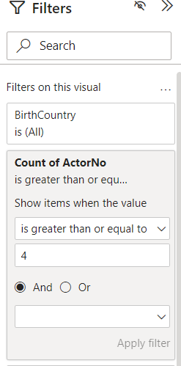

### Pass 2m

Paste your screen capture(s) for this task here.

